TROUBLESHOOTING AND HELPDESK

Assignment Day-1

TASK1: List three real-life scenarios where a multimeter would be used to troubleshoot a computer or smartphone issue, and explain in one line how the multimeter helps in each case.
Scenario | How the Multimeter Helps
Laptop not powering on | Checks whether the charger is supplying the correct voltage.
Smartphone not charging | Measures voltage at the charging port or battery terminals.
Desktop computer randomly shutting down | Tests the power supply (SMPS) output voltages.

TASK2: Watch a short YouTube video demo of a POST card in action (search for 'POST card motherboard test'), then write a brief summary (3-4 lines) describing what the POST card displays and what problem it helped identify in the video.<br><br><em><strong>Hint:</strong> Focus on the codes shown and how they relate to hardware issues.</em>
A POST (Power-On Self-Test) card is used to diagnose motherboard problems during system startup. The card displays hexadecimal POST codes generated by the BIOS while the computer boots. In the demonstration video, the displayed code helped identify a hardware issue related to memory (RAM) detection. By checking the code against the motherboard manual, the faulty component could be identified and repaired.

TASK3: Download and install any free software diagnostic tool (such as HWMonitor, Speccy, or CrystalDiskInfo), run it on your laptop or desktop, and take a screenshot of the main dashboard showing system health details.<br><br><em><strong>Constraint:</strong> Blur or crop out any personal information before submitting.</em>
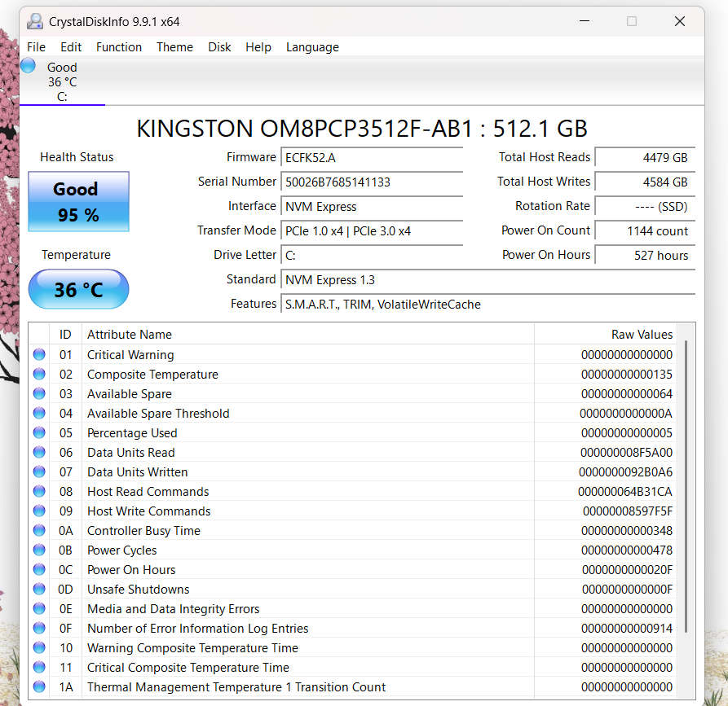

TASK4: Compare the use of a multimeter, POST card, and software diagnostics by creating a table with three columns (Tool, What it checks, Example Problem Detected) and fill in at least one example for each tool.
Tool | What It Checks | Example Problem Detected
Multimeter | Voltage, current, resistance | Faulty laptop charger
POST Card | Motherboard startup codes | RAM or motherboard error
Software Diagnostics | System health and hardware status | High CPU temperature or failing hard drive

